**Lab 3: Linear Power Supply with Zener Regulation**

EE 3310L

Spring 2023

**Alex Yeoh**

Cauy Gibson

Submitted to TA: C. Hicks Friday 7:00 AM

Date of Experiment: 01/27/23

Date of Submission 02/03/23

1. **Introduction**

The purpose of this lab is to build and test a linear power supply with a Zener-diode voltage regulator circuit [1].

1. **Experimental Methodology**

The first step of the experiment is constructing the circuit following figure 1 below, while ensuring the function generator is set to produce a 7.07VRMS (20VP-P), 60Hz sinusoid wave [1].

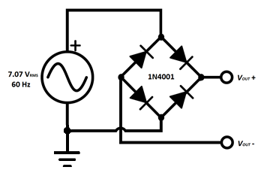

Figure 1. Circuit for exploring the waveform of a full-wave-rectified sine wave.

To measure the waveform generated by this circuit, an oscilloscope will be set to measure the differential between the probes connected to both Vout+ and Vout- with their negative end connected to the common ground in the circuit [1].

After this portion of the lab, the circuit is expanded as shown in figure 2 below [1].

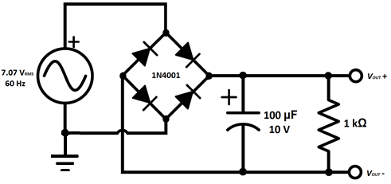

Figure 2: Circuit for exploring the smoothing of a full-wave-rectified sine wave.

This circuit’s waveform is measured in a similar way as with the circuit shown in figure 1 above, while its output voltage can be measured with a multimeter [1].

The circuit is further modified into the circuit shown below in figure 3 [1].

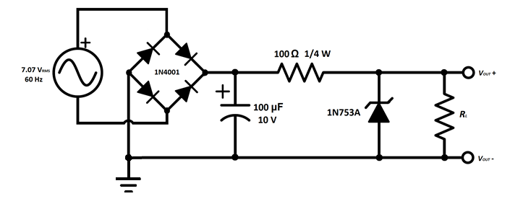

Figure 3: Circuit for exploring a smoothed full-wave-rectified sine wave with a shunt regulator.

The same measurements conducted for the circuit seen above in figure 2 are then applied to this circuit with changing resistor values following the first column of the table below [1].

Table 1. Filled table with VRIPPLE (VP-P) and VOUT(DC) (V) measurements and IL (mA) calculated for a smoothed full-wave-rectified sine wave with a shunt regulator.

1. **Results and Description**

The VRIPPLE (VP-P) and VOUT(DC) (V) measurements for a smoothed full-wave-rectified sine wave with a shunt regulator can be seen above in table 1. IL (mA) measurements as seen in table 1 above, can be calculated with equation 1 below.

$\frac{V_{OUT}-0.5*V_{P-P}}{RL}*100$ (1)

1. **Discussion**

The requested VOUT(DC) vs. IL graph with IL scaled logarithmically and the region where voltage regulator is not effectively held circled can be seen below in figure 4 below.

Figure 4: VOUT(DC) vs. IL graph with IL scaled logarithmically and the region where voltage regulator is not effectively held circled

The observed waveform generated from the circuit depicted in figure 1 above does resemble a full-wave-rectified sine wave. Its peak amplitude is measured to be 10.4V which is close to the theoretical value of 8.6V which is calculated from equation 2 below.

$V_{PEAK}-2V_{D}=\sqrt{2}*V_{s}-2V_{D}$ (2)

The measured DC voltage and peak-to-peak ripple voltage of the circuit depicted in figure 2 above are 7.02V and 0.8V respectively. With these measured values, IL can be estimated to be 0.00702A with equation 3 below.

$\frac{V_{DC}}{R_{L}}$ (3)

The measured ripple voltage is close to the theoretical ripple voltage of 0.585V as calculated by equation 4 below.

$\frac{I_{L}}{2fC}$ (4)

The load current at which the voltage regulator begins to drop out of regulation for the circuit depicted in figure 3 above is 4.98mA. The input voltage at the threshold of drop-out is approximately 19.1V.

1. **Summary and Conclusions**

The lab itself is simple and straightforward to complete due to the instructions given. The lab write-up, however, is a massive burden for a class that does not seem to have the integrated writing attribute listed in the wings express class lookup. This fact feels even more odd due to my previous EE class’s lab only requiring a pre-lab and the given lab sheet filled out to be turned in.

**Reference**

[1] Tritschler, Joe. "Linear Power Supply with Zener Regulation." N.p., n.d. Web. 27 Jan 2023.